Docket Management Facility

United States Department of Transportation

1200 New Jersey Avenue SE

West Building, Ground Floor

Room W12-140

Washington, DC 20590-0001

**RE: Docket No. FHWA-2020-0001, RIN 2125-AF85, National Standards for Traffic Control Devices; the Manual on Uniform Traffic Control Devices for Streets and Highways; Revision**

**Docket Comments FHWA-2020-0001**

**Section 1A.01 - Purpose of the MUTCD**

In order to assure the highest level of transportation safety for the general public, the latest and most advanced traffic control devices need to be sought out, tested and utilized. Practically every innovation today has some form of intellectual property (IP) rights attached because few companies, if any, will spend the time and financial resources necessary for development if the entity is unable to protect the product from theft or knock-offs by competitors. Restricting the use of protected products means that our highways will not be as safe or efficient as possible.

The best means of valued protection for any new innovation comes in three forms: 1) Intellectual property rights, 2) Manufacturing capabilities and 3) Distribution. Only the first form is available to small and disadvantaged businesses because they do not possess the resources, capacity, marketing and established distribution channels.

MUTCD allowance of devices with IP rights creates an equal advantage for companies of all sizes, types of ownership, diversity, and demographics. In addition, IP protects innovative efforts while providing the government with assurance of uniformity, consistency and efficiency on a national basis without the potential from any commercial conflict once the device has been tested and approved. Value pricing becomes available to the government both directly and through licensed vendors.

Exclusion of traffic control devices with existing IP rights from testing or use is an assurance that the MUTCD is not offering the safest possible conditions for all road users.

**Section 1B.05 - Official Interpretations**

Current Text: Unique situations often arise for device applications that might require interpretation or clarification of this Manual. An interpretation includes a consideration of the application and operation of standard traffic control devices, official meanings of standard traffic control devices, or the variations from standard device designs.

*Guidance:*

*Requests for an interpretation of this Manual should contain the following information:*

*A. A concise statement of the interpretation being sought;*

*B. A description of the condition that provoked the need for an interpretation;*

*C. Any illustration that would be helpful to understand the request; and*

*D. Any supporting research data that is pertinent to the item to be interpreted.*

Revision Comments: (Part D under Guidance)

Current *National Work Zone Safety* Information Clearinghouse ([workzonesafety.org](http://workzonesafety.org)) statistics reveal ongoing high counts of speeding and crashes in work zones. With exception of Bus-Involved accidents, across-the-board counts of Fatal Crashes and Fatalities are significantly above the previous 3-year averages. Similar statistics are available showing the ever-present speeding in school zones and many crosswalks locations. These facts clearly indicate that new and different solutions are needed to solve these ongoing problems. The crux: How is it possible to generate and provide supporting research data if unable experimentation with a potential solution is prohibited? The only likely way a unique solution is to be in the public domain is if it is created and produced by the government. This occurs because a private entity will not put any resources into products that cannot be protected from their competitors.

**Section 1B.06 - Experimentation (Item F)**

Restricting experimental devices to only those in the public domain essentially blocks all commercial development of new innovations by eliminating investment incentives and competitive protections. Consequently, the states are unable to consider all products available to solve their particular transportation challenges and lose innovative safety measures that are both cost-effective and shown to have meaningful benefits over existing products.

To be consistent with the November 2018 “Notice of Proposed Rulemaking” by the U.S. Department of Transportation, the MUTCD needs to match the formally receded 23 CFR 635.411 rule that prohibits state and local governments from using patented or proprietary projects on highway and bridge projects. This means Item F in Section 1B.06 Experimentation must be stricken and removed from the MUTCD to provide State DOTs (Departments of Transportation) with greater flexibility to test and use innovative technologies in highway transportation for a safer and more efficient roadway system for American motorists and businesses.

**Section 1B.07 - Changes to MUTCD (Item F)**

The sentence “a change in procedure for recognizing these developments and for introducing new ideas and modifications into the system” needs to be expanded. Currently, the revision only mentions the following items: 1) Consideration of a new device that goes beyond replacement of a standard, 2) An additional device to be added, and 3) revision to an application or placement criteria.

To be effective, the aforementioned list must consider granting permission to create, develop and mold new concepts into actual devices using real world testing as part on the interim approval. Experimentation (as currently defined by MUTCD) begins at a point where the new device has already been completed. The “change in procedure” presently lacks a trial-and-error stage that precedes the revision to an application or placement criteria. Otherwise, the assumption is made that the new device is already an effective solution to the researched problem. This is a “cart before the horse” scenario because it is too costly to crash test every prototype before determining proof of effectiveness.

**Section 1C.01 - Definitions**

A definition of experimentation needs to added to this section whereby the use and testing of a new traffic control device, regardless of patent or other protections, is allowable on the roadway given local cooperation in alignment with a safety deficiency, demonstrated need, stated want by agency, valid reasoning, and/or statistical proof of problem.

**Section 1D.01 - Purpose and Principles of Traffic Control Devices**

To be effective, a traffic control device should a) Fulfill a need, b) Commence attention, c) Convert a clear simple meaning, d) Commence respect from users, and e) Give adequate time for proper response.

Current MUTCD places limitations on the purpose and principles of signage based on several factors:

1. Use of words is the prominent means for message conveyance
2. Only a single language (English) is specified
3. English is a secondary language for a sizeable population of Hispanics citizens
4. Reading words at both distance and speed is a challenging distraction
5. Reading words in a secondary language at distance and speed is a more challenging distraction
6. Sign size can restrict content, readability and comprehension based on word usage
7. Sign size can restrict content, readability and comprehension when translate English to Spanish
8. Sign shape can restrict content, readability and comprehension based on word usage
9. Sign shape can restrict content, readability and comprehension when translated
10. Use of symbols and sign shapes can increase visibility and the speed of comprehension

**Section 1D.03 - Uniformity of Traffic Control Devices**

Sign uniformity is designed to assist quickly convey a specific message to road users. The goal is to get the attention of drivers, minimize reading distractions, and increase comprehension. At present, the vast majority of roadway signs rely too heavily upon reading words in English. Sign shape is vastly underutilized with a predominance of messaging by the ever-so-common rectangular shape used by both the public and private sector. The primary emphasis on single language words for instruction causes problems for those whose primary language is not English. Even when graphic symbols are utilized, placement onto a standard sign shape reduces its overall size, attention-grabbing capabilities, and readability at distance. The use of sign shapes as means for differentiation and conveyance is severely lacking. Both comprehension and reading diversions detract from the driver’s focus and increase their reaction time.

Message uniformity assists road users, law enforcement officers, and traffic courts by giving everyone the same interpretation. Uniformity also creates efficiency in the manufacturing, installation, maintenance, and administrative rulings.

This section needs to address seven (7) major challenges that arise with respect to signs:

1. Used of Different Languages
2. Readability of Letters at distance and speed
3. Message Comprehension at distance and speed
4. Posting height, visibility, and environmental conditions for temporary signage
5. Classification system for treatment of signage as permanent vs. temporary
6. Increased differentiation of temporary signage based on duration of use
7. Reevaluation of signage for serious, repeated or multiple accidents

*Further Clarifications of Message Conveyance Challenges:*

Current MUTCD assumes that all viewers can read and comprehend English. Given the demographics of United States as well as predominance of Hispanics in our society and on construction teams, effective notification should be in both English and Spanish. By addressing this discrepancy for increased safety, the sign count will double MUTCD, calling for a strong need to utilize more symbols and shapes to minimize sign counts.

It can be very difficult to read words on a sign when driving, especially so when traveling at speed with other traffic. The problem is compounded by blockage when traveling amongst larger vehicles, SUVs, vans, pickup trucks, tow trailers and commercial cargo vehicles.

Further reading and blockage challenges are created when temporary signage is placed low to the ground in work zone to minimize the effects of blowing wind and/or unpredictable gusts. This compensation makes the sign susceptible to road splatter which can obstruct or cover up the safety messaging. In contrast, high placement is uncommon because the signs need to be moved often by a single construction worker. Such temporary structures for high mountings are challenging to relocate or do not exist.

The current MUTCD does not provide sufficient differentiation between temporary and permanent signage. Regulations for placement and postings in work zones will differ from new construction or repairs/rebuilds having longer duration. Sign size, traffic flow, re-routing, volumes, and speeds differ for maintenance, repairs, lane expansions, shoulder work, and emergency closures. Similarly, temporary signage for crosswalks and school crossings differs from permanent postings and needs further clarification given the challenge to see the short/narrow median marker and hand-held models less than a half block away.

The MUTCD has little to no mention about the reevaluation of signage regulations based on specific conditions of resulting accidents.

**Section 1D.08 - Public Domain, Copyrights, and Patents**

***Traffic control device design or application provisions contained in this Manual shall be considered to be in the public domain. Traffic control devices contained in this Manual shall not be protected by a patent, trademark, or copyright, except for the Interstate Shield, 511 Travel Information pictograph, and any items owned by FHWA.***

Why can a product owned by the FHWA be protected by a patent, trademark or copyright and not so for a private company, especially when the company pays ongoing fees to the USPTO and pays taxes to the government for purchases, sales and profits?

There is a definitive conflict that exists between the use/want of innovation and public domain. The Manual’s stated need for uniformity clearly beckons for the use of protection granted by the USPTO. This statement holds true because a company needs some form of protection in order to recoup their investments and fend off other entities who would make different versions in order to remain competitive. The granting of protection by one division of the U.S. Government for use by another division of the U.S. Government assures uniformity by allowing the developing company to license a successful product to as many subcontractors as need to keep the purchase price reasonable.

The following sentence needs to be revised or stricken in accordance with the want for innovation and the corresponding revision that was made to the Federal Register: *A traffic control device design or application shall not be eligible for official experimentation (see Section 1B.05) or interim approval (see Section 1B.07) unless it is in the public domain.*

The next sentence mentions the universal requirement to be in the public domain: *Express abandonment of any and all forms of proprietary protection, such as patents, trademarks, or copyrights, related to the design and application of the traffic control device shall satisfy the requirement for the traffic control device to be in the public domain.* Further exploration of the MUTCD reveals there is no detail providing clarification as to the scope and wording associated with express abandonment.

The next statement addresses individual components: *The requirement for the traffic control device to be in the public domain shall not apply to individual components used in the assembly or manufacture of the traffic control device.* This statement needs clarification because every part, visible or not, is a component of the product.

The public domain limitation on traffic control devices based on the message conveyed to the road user needs revision. With respect to road signs, the overall goal is to convey the message as quickly as possible to the users so that proper and safe navigation can occur. Hills, curves, distance, speed, placement, traffic, weather and lighting conditions have a greater definitive effect on the rate of message conveyance more so than the public domain messaging. In other words, the current MUTCD restrictions for sign shape and its use of language or symbols can be more of a hindrance to the conveyance of the needed message.

Cases in point:

1. Rapid conveyance depends on the word count and meaning of those words
2. Word counts differ based on the language utilized
3. Word counts and letter sizing are affected by the shape of the sign
4. Most of the current standard sign shapes do not convey any meaning without words or symbols
5. Comprehension of the symbols depends on distance and its overall size
6. Symbol size is limited based on the size and shape of the standardized sign

The limiting the messaging capabilities in order to preserve uniformity does little good when a driver has limited time to view the standardized sign. Safety is decreased when a driver is faced with a natural or man-made condition (Hills, curves, distance, speed, placement, traffic, weather and lighting conditions) because conveyance with full comprehension can effectively distract the driver from performing the needed action. Consequently, the government needs to allow experimentation with new innovations (lighting, shapes, forms, positioning and other technologies) that convey an understood message as quickly as possible. The phrasing must be changed to accommodate the use of other protected devices that utilize visual, audio or mechanical means for driver assistance and safety. Present city, county and state transportation officials will not allow experimentation of any type unless the MUTCD mentions the ability to to experiment with other traffic control devices that have patent or other protections in place. Without the ability to experiment with these other devices, the presence of intellectual property rights renders the device exclusionary. The limitations, especially that for conveyed message to road user, should not be all inclusive.

**Section 2A.10 - Sign Boarders**

Not all signs need a sign boarder. In fact, use of a boarder can take up precious sign space and require that smaller words and/or symbols be utilized.

**Section 2A.11 - Enhanced Conspicuity for Standard Signs**

An extensive list of options are provided here to help grab the attention of drivers and convey a desired message. The art of innovation often comes not only through device enhancement, but based on an analysis of the core problem or device. Consequently, this section should provide the option to experiment with alternatives to the standard regulatory warning or guide signs. The listing of 13 approved methods for enhancement (plus support measures) typically indicate that the base product for message conveyance may be ineffective.

**Section 2B.11 - Yield Signs**

The mentioning of this section is used to illustrate a point. These signs containing both words and symbols can convey an appropriate message for unsignalized pedestrian crosswalks when viewed with sufficient time at a suitable distance. However, time and speed cause the words and symbols to be illegible and ineffective. There are just too many elements to process quickly unless time was taken previously to comprehend the message. One also gets the sense that these devices were created simply to by combining signs in order to reduce the count of posted signs.

**Section 2B.19 - Yield to Here Pedestrian Signs and Stop Here for Pedestrian Signs**

As mentioned in 2B.11 above, these R1-5 Series signs can be confusing regardless of viewing time or distance. Previous comments suggest the need for innovation to slow down traffic and avoid serious accidents with pedestrians. Submissions from outside the public domain should be allowed for experimentation given the current end products made for this ongoing problem. Applications include both crosswalks and school crossings.

**Section 2B.2 - In-Street Crossing Signs**

The current R1-5 and R1-6 signage and its stated limitations (Content, height, placement, protection, etc.) beckons for experimentation given the frequency of being struck by vehicle and the need for ongoing replacements. Public domain requirements create exclusionary results from viable low and high-tech solutions.

**Section 6L.02 - Automated Flagger Devices**

This section states there are only two types of AFADs. To open the door to innovation, a comment should be included to indicate that other alternatives are possible through experimentation.

**Section 6L.03 - Stop/Slow Automated Flagger Devices**

This section details specific parts, signage and various elements like striping. The edits to improve flexibility should focus on the achieved effect on traffic, not the list required elements. The purpose of the AFAD should be about performing one or two key tasks with high effectiveness rather than creating the impression of a Rube Goldberg device that tries to take on every tasks typically performed by a human. The reference to Rube Goldberg is made because many drivers have a tendency to ignore such a machine… causing the traffic problems the device is trying to solve.

**Section 6L.04 - Red/Yellow Lens Automated Flagger Devices**

The comments made for Section 6L.03 apply here as well. In addition, the flexibly to eliminate the gate arm needs to be address. Changing this particular element into an option is mentioned because the gate arm for most current products is practically invisible at distance and speed. The lack of visibility creates the high possibility of damaging/moving the AFAD when struck… rendering the entire device to be totally ineffective. Besides, the drivers should and need to be focused on the key messaging rather than the gate.

**General Comments - MUTCD Revisions**

The frequency of MUTCD revisions or updates need to be in sync with today’s online technology. In other words, the online version should constantly reflect the current status of all FHWA Approvals without linking everything back to a specific revision year. All of the same procedures and timelines for experimentation, interim approvals, submission of comments, review, decision making, and posted notices remain the same. However, once the FHWA grants an approval and posts it online, the MUTCD always remains current. There is absolutely no need to wait and post a gathered collection of updates to the Manual on a specific date. This process would be more akin to a specific rulings by the Supreme Court whereby the system immediately reflects today’s current law.

**Contact Information**

Craig Canon 303-988-0600

Zone Crew Safety [craig@ZoneCrew.com](mailto:craig@ZoneCrew.com)

Thank you for addressing these comments. Please reach out for further information and/or discussion.

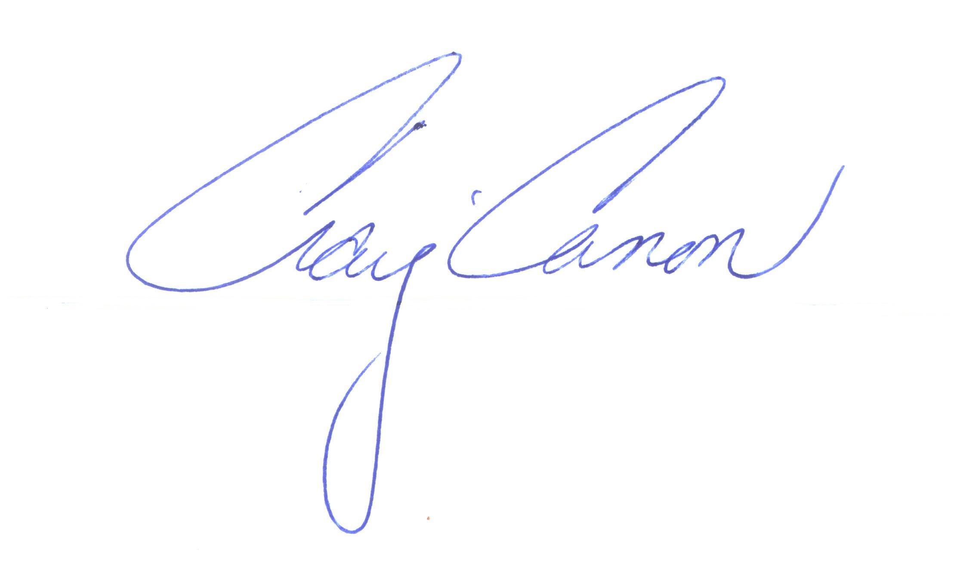

Craig Canon